Dear professor Zhou,

My name is Peng TIAN, my ID is 5354870. My group is in your CSCI926 Autumn 2020.

Our project topic is: metamorphic testing for perception module of AI autonomous driving system aim for Australian specific Road Signs - Animals and Horse Riders (software-in-the-loop).

Would you please have a look at our project to make sure that we are on the right track.

Our program is based on Matlab – Traffic Sign Detection and Recogition (TSDR) (<https://au.mathworks.com/help/gpucoder/examples/code-generation-for-traffic-sign-detection-and-recognition-networks.html>).

Our system contains several functions:

1. Traffic Sign Detection and Recognition (TSDR)

[boundingBox, class] = tsdr_predict_thresh(image, thresh)

(this function detects traffic signs from an image, return the boundingBoxes and classes of signs. This function is manipulated from TSDR so that can accept the thresh value of probability.)

1. Replace Traffic Sign (RTS)

[image] = rts(image, old_sign_boundingBox, new_sign)

(This function use a new image - new_sign to replace the special area of old_sign_boundingBox in image.)

1. Environment Synthesis (ES)

[image] = es(image, category)

(This function simulates special environment into the image such as fog, rain, dusk …)

1. Save Image (si)

[] = si(image, format, full_path_name)

(This function save image as special format.)

With these function, we can build various flexible testing system and generate infinite test cases buy making different combinations and setting different parameters.

For example, there are V videos and each video contains S signs, there are N new signs. Then we can generate V*S*N new test cases. With different environment synthesis, these can be more.

In addition, we can save the new test case as video file so that can be used for the third system, or we just test these cases using Matlab TSDR.

Two videos:

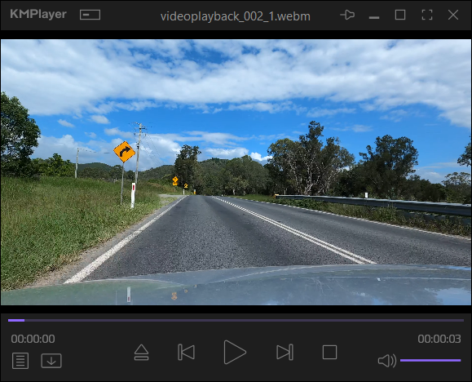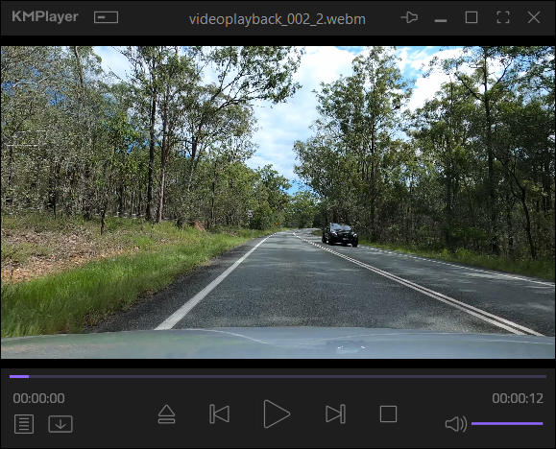

Two new signs:

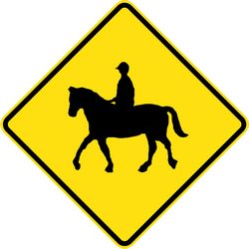

environment synthesis – fog(density = 0.1)

Performance video:

<https://uowmailedu-my.sharepoint.com/:v:/r/personal/pt882_uowmail_edu_au/Documents/CSCI926_share_point/Figure%201%202020-05-07%2012-55-19.mp4?csf=1&web=1&e=6fkQRl>

Performance Screen shots:

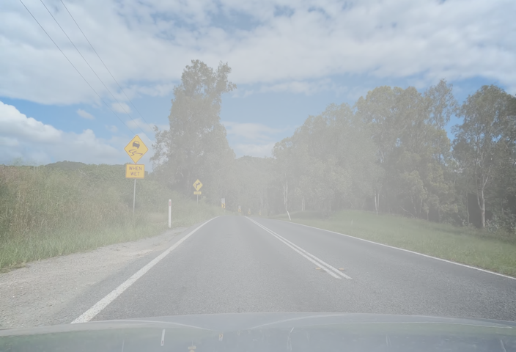

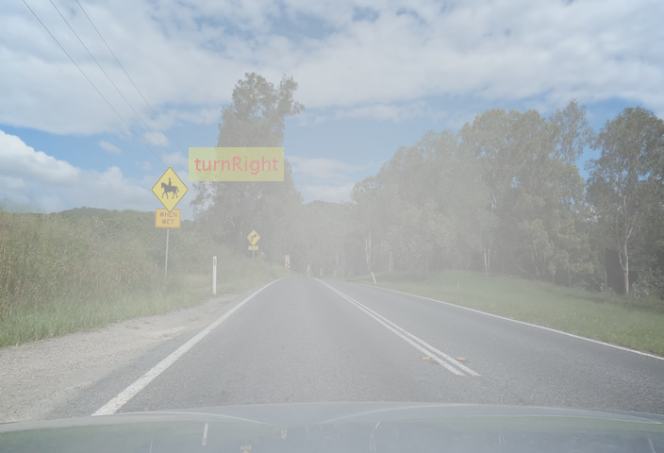

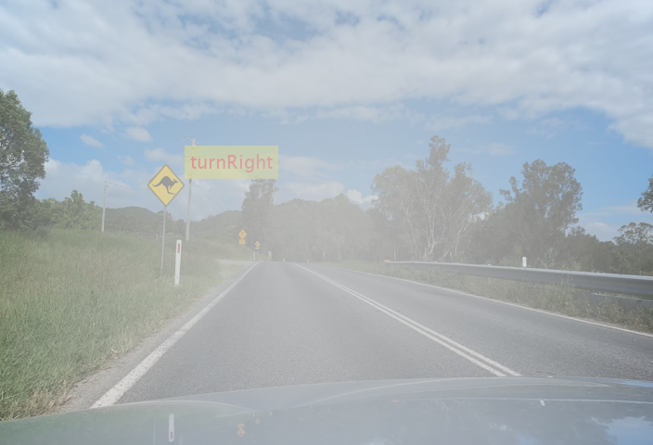

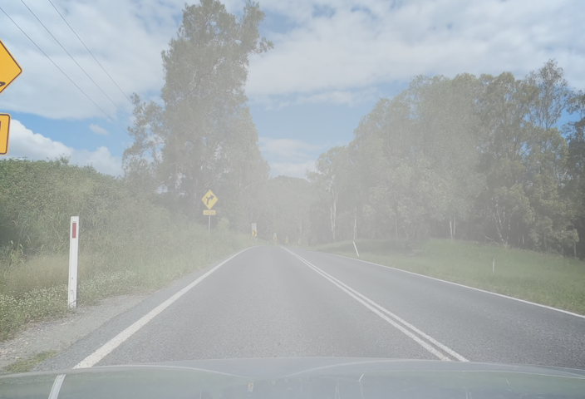

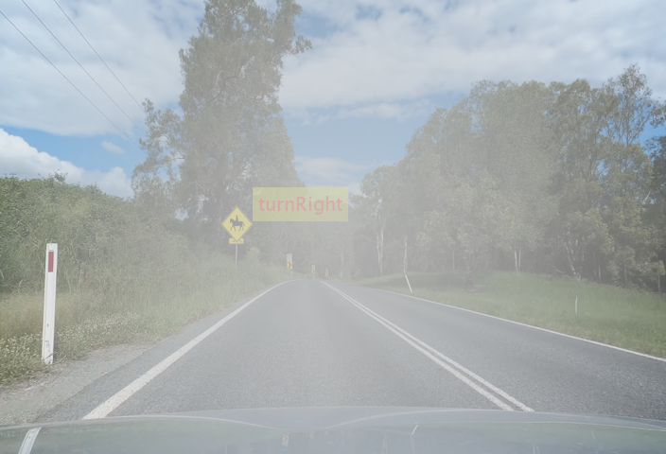

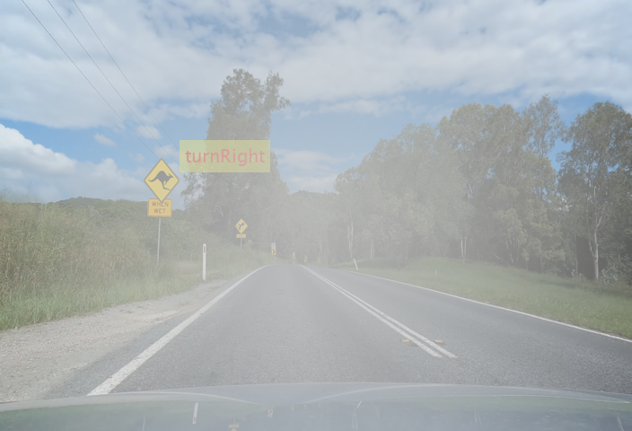

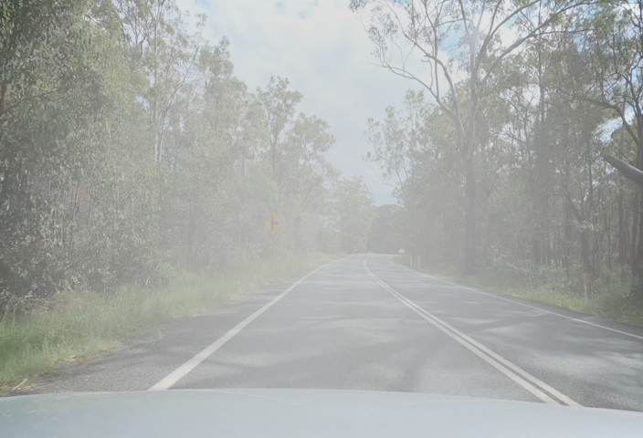

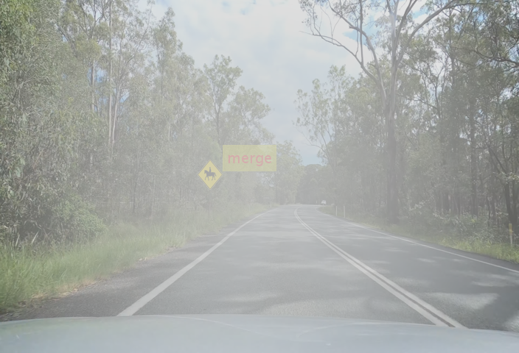

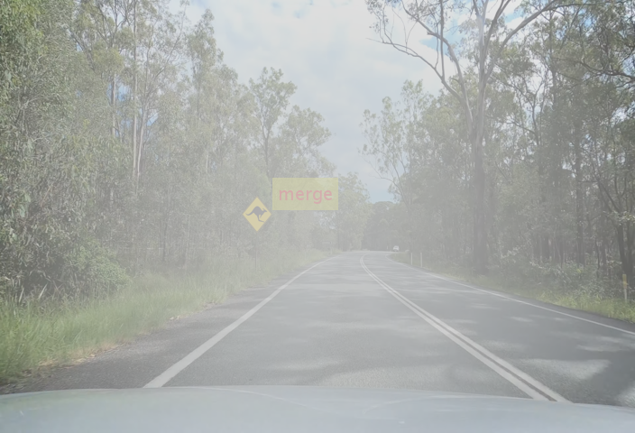

Why we choose this kind virtual reality fusion tech? Because it is :

1. Real, contrast to virtual environment
2. Cheap, contrast to computer-generated imagery (CGI)

Have a good day.

Cheers